Test Input Chart

|  |  |  |  |
| --- | --- | --- | --- |
| Input(method/in) | Expected(result/efficiency) | Output(result/efficiency) | Pass/Fail |
| Iterative/5 | 29/5 | 29/5 | Pass |
| Recursive/5 | 29/5 | 29/5 | Pass |
| Iterative/0 | 0/0 | 0/0 | Pass |
| Recursive/0 | 0/0 | 0/0 | Pass |
| Iterative/1 | 1/1 | 1/1 | Pass |
| Recursive/1 | 1/1 | 1/1 | Pass |
| Iterative/2 | 2/2 | 2/2 | Pass |
| Recursive/2 | 2/2 | 2/2 | Pass |
| Iterative/130 | 8909436761397750914/130 | 8909436761397750914/130 | Pass |
| Recursive/130 | 8909436761397750914/130 | 8909436761397750914/130 | Pass |
| Iterative/-1 | Error Window | Error Window | Pass |
| Recursive/-1 | Error Window | Error Window | Pass |
| Iterative/131 | Error Window | Error Window | Pass |
| Recursive/131 | Error Window | Error Window | Pass |
| Window Close | Out.txt/0-10 in csv format | Out.txt/0-10 in csv format | Pass |
| Window Close  File Protected | Error Window | Error Window | Pass |

Compilation and resulting GUI windows:

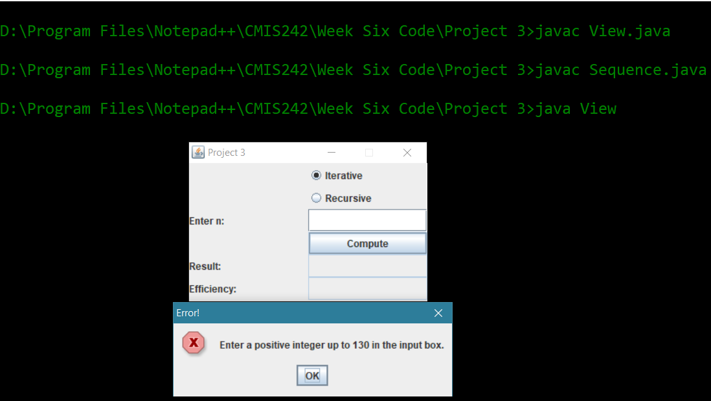

Resulting Chart from out.txt:

Issues:

I am unable to find any way that either the iterative or recursive algorithm are anything but linear in complexity. I understand the theory of the recursive algorithm which creates a new copy of the variables each time it is called, then passes them back to the previous method call to determine the answer, but it seems that the method is only actually called once per number in this method.

Limitations:

The method is limited by the length of a long (64 bits) which means the highest nth degree I can find is 130 before the number becomes distorted. I tested this edge case and the results are in my chart above. I added a new NumberFormatException to handle this and will not allow input below zero or above 130 so as to keep the program from entering an infinite loop, or returning a distorted number.

Test Case Runs:

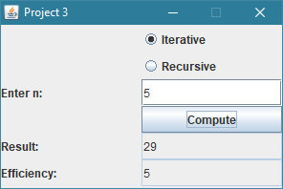

Test of input iterative/5

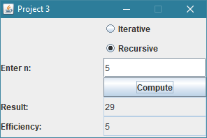

Test of input recursive 5

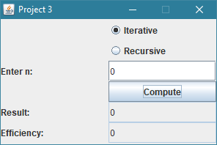

Test of input iterative 0 (edge case)

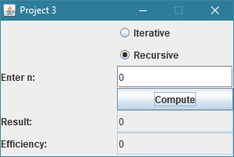

Test of recursive 0 (edge case)

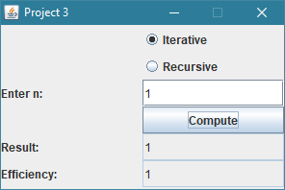

Test of iterative 1

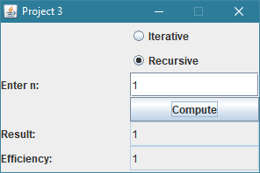

Test of recursive 1

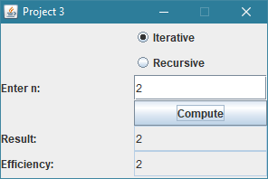

Test of iterative 2

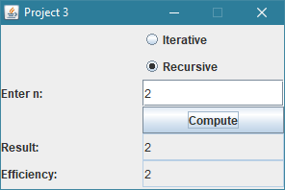

Test of recursive 2

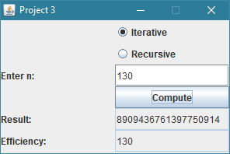

Test of iterative 130 (edge case)

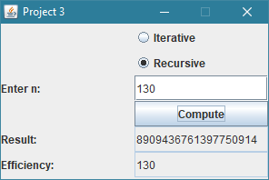

Test of recursive 130 (edge case)

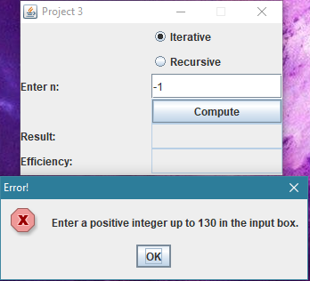

Test of iterative -1 (edge case)

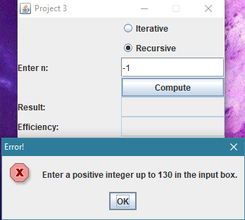

Test of recursive -1 (edge case)

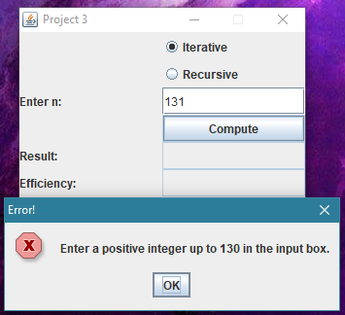

Test of iterative 131 (edge case)

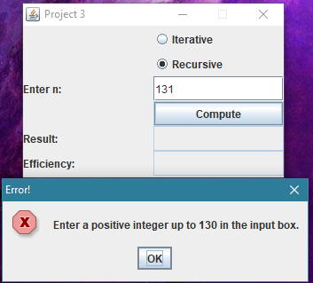

Test of recursive 131 (edge case)

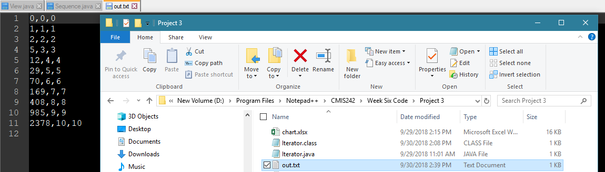

File written after window close in csv format



Setting permission to deny write permission

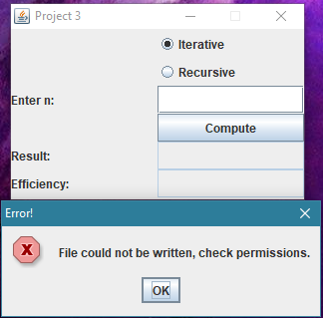

Failed attempt to save the file displays the error window